**Adder code:**

import java.rmi.*;

public interface Adder extends Remote{

    public int add(int x,int y)throws RemoteException;

}

**Adder Remote Code:**

import java.rmi.*;

import java.rmi.server.*;

public class AdderRemote extends UnicastRemoteObject implements Adder{

    AdderRemote()throws RemoteException{

        super();

    }

    public int add(int x,int y){return x+y;}

}

**Client Code:**

import java.rmi.*;

public class Client{

public static void main(String args[]){

        try{

            Adder stub=(Adder)Naming.lookup("rmi://localhost:5000/jinxx");

            System.out.println(stub.add(34,4));

        }catch(Exception e){}

    }

}

**Server Code:**

import java.rmi.*;

import java.rmi.registry.*;

public class Server{

public static void main(String args[]){

        try{

            Adder stub=new AdderRemote();

            Naming.rebind("rmi://localhost:5000/jinxx",stub);

        }catch(Exception e){System.out.println(e);}

    }

}

**Registry Output:**

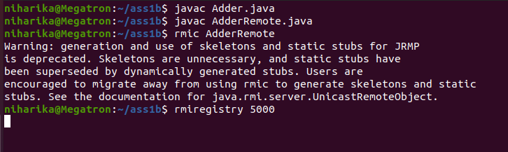

**Server Output:**

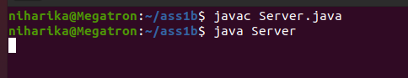

**Client Output:**

